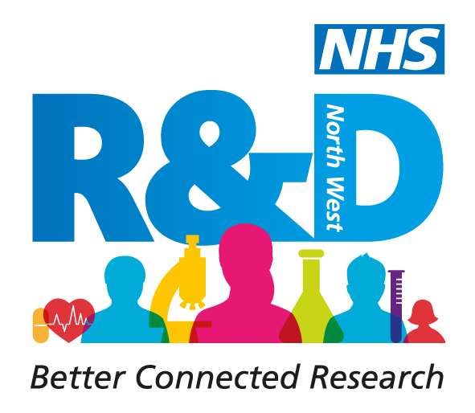
NHS Research & Development North West Conference
Let’s Talk Research
17th & 18th September 2015

Abstract Submission Form for workshops
For the 2015 conference we are opening up abstract submissions to groups or organisations who are interested in leading a workshop during the conference. We are seeking workshops which focus on one of the following areas:

The development of early career researchers
The development of cultures of research and innovation within the NHS
Novel and innovative approaches to communicating research

Please note that workshop sessions will last for 1 hour and may have up to 50 participants. We especially welcome sessions which are interactive.

Please provide the following information in the submission form:

- Overarching aim(s) of session
- Learning outcomes for the session
- Content of session
- Suggested format including timings
- Length of submission document should be a maximum of 500 words
- Complete all text within the clear boxes provided in 12pt Arial.

All workshop leaders will be required to register for the conference and pay the full registration fee.

Workshop abstract submission form

Name of workshop leader:
First |  |  |  | Last |  | Title
Affiliation e.g name of employing organisation

Names of additional workshop leaders |  |  | 1. Name  Affiliation
2. Name
Affiliation
3.Name
Affiliation
4. Name
Affiliation
5. Name
Affiliation
Title of workshop
Abstract (500 words maximum). This is an expandable box and will accommodate the word limit.

Keywords (maximum 3)
References (maximum of 3)
AV Requirements

The deadline for submitting abstracts is 5pm Monday 23rd March 2015.

Please submit completed forms to Leanne.gregory&researchnorthwest.nhs.uk

