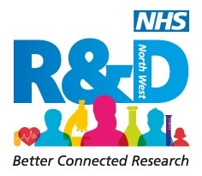

The Academy of Creative Minds 2017
Application Form
Bringing the arts and science together in health research

- Two-day residential starting from 5pm on 23rd June to 25th June 2017 at Lancaster University
- 4 mentoring workshops 6th July, 20th July, 7th September
- Presentation of your work at the regional NHS R&D North West annual conference on 14th September 2017.

(If applying as a team please complete one form for each team member)

Title

First name

Surname

Job title

Employing organisation

Contact telephone number
Email

Summary of your completed research
(Maximum 500 words)
This should include the research question addressed, a description of the methods used, the findings, where these have been published (or submitted, if to a funder, commissioner, or public body) and the key messages that you now want to get across to practitioners, patients, the public and/ or policy makers.

Please list the 3 key things you hope to achieve as a consequence of participating in this programme?
Are you attending as part of a team  If yes please list your team members | Yes No (please circle as appropriate)  1.  2.  3.  4.
How will you be funded? | Self Employer Other (please state)…………….

Please return to Leanne.gregory@researchnorthwest.nhs.uk

